Citizens for a Strong Oshkosh
Visit us on the web: http://csoshkosh.weebly.com/ and https://www.facebook.com/citizensforastrongoshkosh
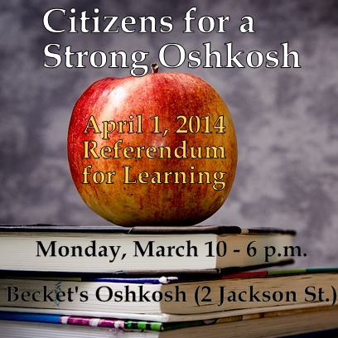
Community Conversations: Consider Public Education
Citizens for a Strong Oshkosh is proud to announce and host a public conversation on the referendum advanced by the Oshkosh Area School District. The CSO Conversation will be held at 6:00 p.m. on Monday, March 10 at Becket’s (2 Jackson St, Oshkosh, WI 54901). The meeting will be held in the front enclosed glass room. (Participants can order food or drink from the bar as part of this evening out.)
CSO Conversation – Consider Public Education
Focus on the School Referendum
Proposed by the Oshkosh Area School District (April 1st election)
Monday, March 10, 2014 ~ 6-8 p.m. (Becket’s)

Invited Presenters:
- Stan Mack (OASD) &
- David Gundlach (OASD)
- Karl Loewenstein (citizen advocate and former school board member)

About the Referendum for Learning

Advanced Unanimously by the Board of Education, Oshkosh Area School District:

- On April 1, 2014, residents of the Oshkosh Area School District will be asked to decide whether the school district should be able to increase its funding to support student learning.
- If approved by voters, the Referendum For Learning would provide $3.95 million per year for seven years to protect academic programs for students and improve technology for teaching and learning.
- If not approved by voters, Oshkosh will need to make $2.5 million in cuts that will affect the classrooms and will be unable to make important investments in technology for students and teachers that have been outlined in the district’s strategic plan.

Questions to Consider:

- What are the “basic facts” about the referendum?
- In what ways will the referendum strengthen, improve and enhance the educational quality provided by the Oshkosh Area School District?
- How is the quality of life (i.e. living and working in Oshkosh) impacted by the Oshkosh Area School District?

About CSO: Citizens for a Strong Oshkosh is an open, inclusive and non-partisan community-based organization. Many public issues and political discussions seem to be framed in an “either/or” model that highlights tradeoffs and choices between limited options. We seek to broaden this discussion to explore or consider more options and possibilities.
The following beliefs unite those who join in this common purpose:
- We believe in a future of hope, promise and genuine distinction for greater Oshkosh area.
- Although we have different points of view, we are united in the belief that the process of community-based discussion and conversation is an important and often neglected part of the process of leadership and governance.
- We believe civic advancement requires open, objective and fact-based discussions, dialogues and even pointed debate.
- We believe our combined efforts are important and necessary to keep our community strong.

